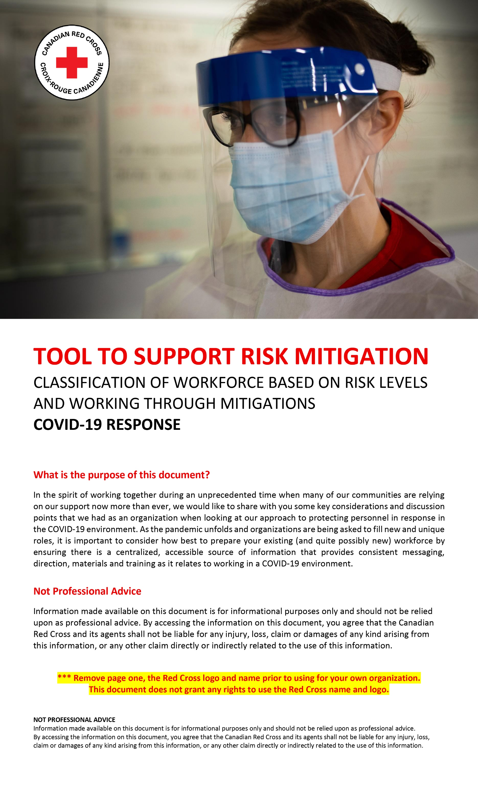

CONSIDERATIONS IN CREATING A WORKFORCE CLASSIFICATION BASED ON RISK LEVELS FOR COVID-19

This section sets out the purpose of the document and background information that you can
amend for your own purposes based on your organization type, nature of the services and workforce.

Audience / Users: Consider people/personnel who are going to use this document for guidance as well as high-level parameters around intended use. For example: “Personnel (in particular, supervisors/managers and Human Resources), to determine program/service requirements relating to safe work practices and preventative measures associated with the COVID-19 pandemic situation.”
Date of Publication: [Insert: Date last updated]
Distributor and Approver: Consider Department/Team(s) accountable and responsible for content of document
Editor and Updated Versions From: Consider Department/Team(s) accountable and responsible for any changes made to document

Application: Consider intended application of document, instruction on how/when changes should be made, who is responsible for making/approving changes, and considerations made in assessing the weight (importance) of directives. For example: “These directives will inform workforce classification and the establishment of protective standards around this classification. Any changes, adaptations or clarification considering these standards will be the responsibility of [insert: department/team(s) responsible for making and approving changes]. Considerations to assess the weight (importance) of associated risks for determining the required protective measures should include the epidemiology of the disease and characteristics of workplace settings, including the vulnerabilities of our workforce and clients. This guidance should be subject to change as new information emerges on COVID-19 transmissibility and epidemiology and could include advice and recommendations for modifications to programing approaches.”

Approach to advice and guidance: List guiding principles that were used to develop protocols/processes. For example: An evidence-based approach was used to develop the protocols and processes while also endeavouring to be responsible stewards of personal protective equipment (PPE) in this time of shortage. Decisions made balance current evidence, the organizational mandate and the risk threshold.

Review and updates: Identify intended/desired review intervals and who should be involved in the review. For example: Review of this document will be conducted on a regular basis and as new reputable information becomes available. Relevant SMEs will be consulted as required.

This section sets out the relevant definitions applicable to the whole document that you can add to and amend for your own purposes based on your organization type, nature of the services, and workforce.

Definitions: Include relevant definitions to support content in chart such as:

- COVID-19 Symptoms: The Public Health Agency of Canada (PHAC) states those who are infected with COVID-19 may have little to no symptoms or may become very ill. Symptoms of COVID-19 are similar to many respiratory illnesses such as a cold or influenza. The most common symptoms are cough, fever, difficulty breathing. PHAC has developed a self-assessment tool for individuals who think they may have COVID-19. This tool provides guidance to the user based on their response to each assessment question and includes health guidance: (reference relevant public source).

- Asymptomatic: Showing no signs or symptoms of disease (COVID-19), whether the disease (COVID-19) is present. Harvard online Medical Dictionary. *For the purposes of this document, “asymptomatic” refers to “COVID-19 asymptomatic”.

This next section is helpful as a frame to help you work through risk levels, workforce types and
the mitigation relative to each. Once finalized the working document can be used to record your organizations policy or approach as well as to guide personnel management practices.

CLASSIFICATION | Group A | Group B | Group C | Group D
Level of Risk | HIGHER RISK  (i.e. Client-facing) | MEDIUM RISK  (i.e. Client-facing) | LOWER RISK  (i.e. Not client-facing) | STANDARD PUBLIC RISK  (i.e. Not client-facing)
 | [Insert: relevant services/  program label(s)]  i.e. in community, facility based, etc. | [Insert: relevant services/  program label(s)]  i.e. in community, facility based, etc. | [Insert: relevant services/  program label(s)]  i.e. office, deliveries at operational sites | [Insert: relevant services/  program label(s)]  i.e. Call centres, remote work
Client Assumptions / Characteristics | [Insert: assumptions or reason for “Higher Risk” classification].  i.e.: Clients are symptomatic or COVID-19 positive  For example - Higher risk because individuals interacting directly with COVID-19 clients. | [Insert: assumptions or reason for classification of “Medium Risk”].  i.e.: Clients are asymptomatic at the onset/entry to service  For example - Medium risk because clients may become symptomatic or COVID-19 positive. | [Insert: assumptions or reason for “Lower Risk” classification].  i.e.: Personnel is not client facing  For example - Lower risk because there are no projected or anticipated interactions with symptomatic or asymptomatic clients. | [Insert: assumptions or reason for “Standard Public Risk” classification].  i.e.: No interactions with symptomatic or asymptomatic Clients
Work profiles | [Insert: work profiles along with examples of roles specific to your organization]  i.e. health and home support services, generalists, emergency responders | [Insert: work profiles along with examples of roles specific to your organization]  i.e. health and home support services, generalists, emergency responders | [Insert: work profiles along with examples of roles specific to your organization]  i.e. administrators / management | [Insert: work profiles along with examples of roles specific to your organization]. Consider call centres, remote workers
Program type and Location | List and describe the types of programs and where the programs take place | List and describe the types of programs and where the programs take place | List and describe the types of programs and where the programs take place | List and describe the types of programs and where the programs take place
Infection Protection Control (IPC)  or whatever you are calling your measures to protect against transmission internally | Consider protocols around infection protection control such as social/physical distancing between persons (including fellow personnel and clients) supported by stickers and markers where required, point of contact screening for COVID-19 symptoms, reinforcement of personal and environmental hygiene practices (i.e.: hand hygiene, respiratory etiquette, keeping your hands away from your face, clean/disinfect high touch surfaces frequently, keep away from those that are ill, and stay home if you are sick), access to PPE, carrying/disposal of personal protective equipment (PPE), plastic shields for staff members etc. For example – using stock scripts used by front line service workers prior to engaging in service, reorganizing layouts, having only one entry and exit etc.  Any potential Screening for COVID-19 symptoms; with the clients.  ** This can be broken down by Group, for example: more equipment for Group A versus Group D.
Personal Protective Equipment (PPE) | Personal Protective Equipment (PPE):  Based on the type of service you’re providing and in accordance with recommendations of reputable public health authorities, medical journals, global health bodies etc., determine the most appropriate PPE such as gloves only, 2-piece or 4-piece PPE. (i.e. 2-piece PPE might include a procedure mask and gloves, 4-piece PPE might include a face shield, procedure mask, gown and gloves.)  ** This can be broken down by Group, for example: more equipment for Group A versus Group D.
Reporting IPC Breaches | Consider whether personnel have a positive obligation to report breaches and provide direction on how breaches should be reported, to whom and timeliness of reporting. Align to your internal incident management protocols if you have them.
IPC Measures for Clients | Consider direction/instruction that should be asked of clients, measures that will be taken to facilitate the direction (i.e., provision of hand sanitizer, masks etc.) in order to protect your personnel and the community.
Risk information provided | Provide personnel with information on risks, measures to reduce the risk and an opportunity to ask questions. Will the organization require any additional information or attestations from personnel (i.e. confirmation that they are feeling well, etc.) for the types of tasks / activities personnel will be supporting. Ensure that any sensitive, personal or medical information collected is stored securely and in line with relevant legislation.
Briefings required | Consider any briefings required such as Health and Safety, Operations, Security, Human Resources etc.
Training required | Based on services provided, consider training needed for any additional COVID-19 related response such as hand hygiene or any donning and doffing of PPE.
Monitoring and isolation period required | Include directives around monitoring and isolation protocol. In accordance with the recommendations of reputable public health authorities, medical journals, global health bodies etc., consider type of health monitoring (i.e., temperature check), frequency (i.e., twice daily) and duration (i.e., two weeks) as well as protocol around isolation based on services provided.

References such as Public Health Agency of Canada / World Health Organization/ Centre for Disease Control as deemed applicable by your organization

