Ukraine Humanitarian Crisis – Shot List
Shoot Date: January 2023
Location: Ukraine – Lviv
Please Credit: Canadian Red Cross

No | Time | Description | Location | Cast | Screenshot
1 | 00:00 - 00:06 | Exterior of Lviv Clinical Hospital of Emergency and Intensive Care. | Lviv, Ukraine | N/A | 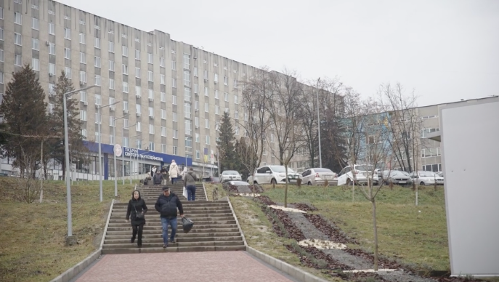
2 | 00:06 – 00:13 | The front entrance of Lviv Clinical Hospital of Emergency and Intensive Care. | Lviv, Ukraine | N/A | 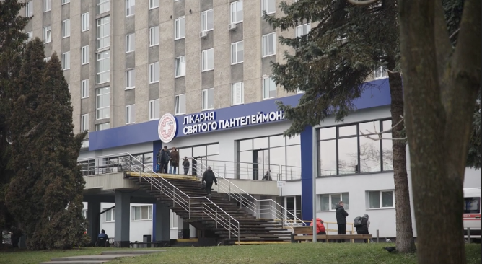
3 | 00:14 – 00:21 | Ambulances outside the front entrance of Lviv Clinical Hospital of Emergency and Intensive Care. | Lviv, Ukraine | N/A | 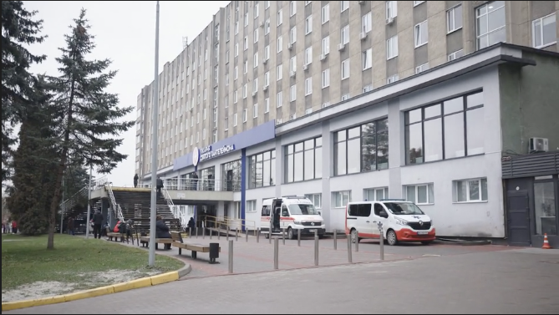
4 | 00:21 – 00:24 | A newly arrived patient at Lviv Clinical Hospital of Emergency and Intensive Care speaks with Dr. Oleh Berezyuk and a colleague from the psychotherapy team while she completes physical rehabilitation exercises. This young woman was injured by shelling in Kyiv and has a brain injury as a result. She is receiving mental and physical rehabilitation at the hospital. | Lviv, Ukraine | Dr. Oleh Berezyuk  Patient  Nurses | 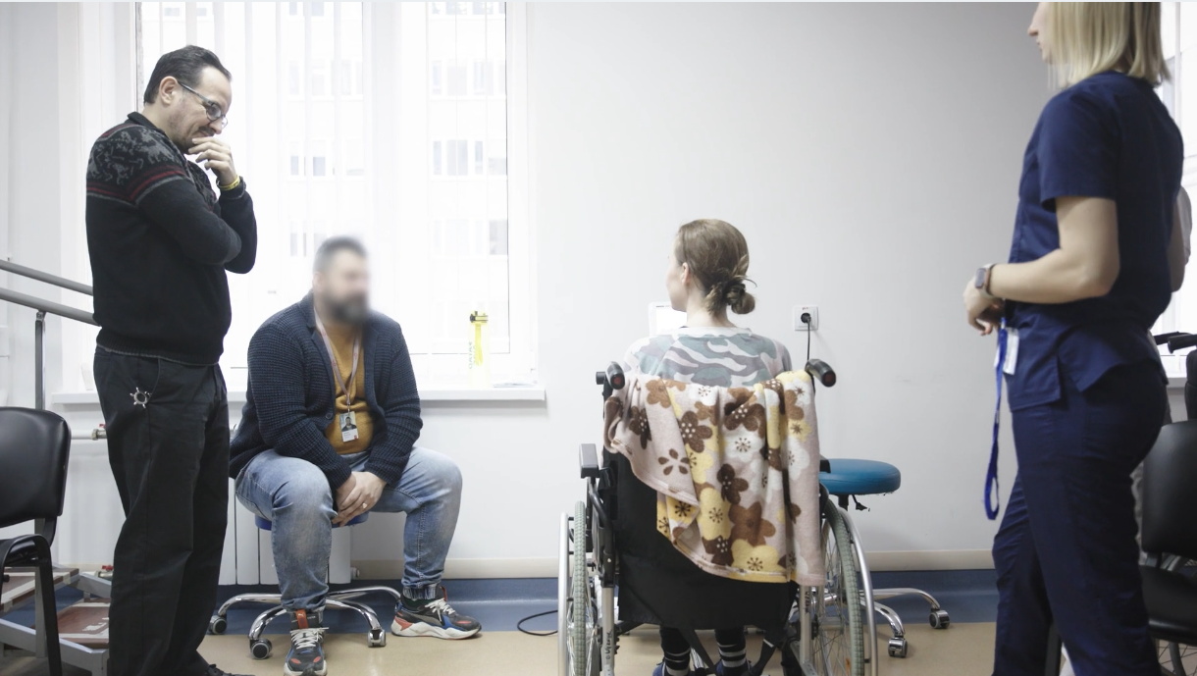
5 | 00:24 – 00:30 | Dr. Oleh Berezyuk the psychotherapy team speaks with a newly arrived patient (out of frame) while she completes physical rehabilitation exercises. This young woman was injured by shelling in Kyiv and has a brain injury as a result. She is receiving mental and physical rehabilitation at the hospital. | Lviv, Ukraine | Dr. Oleh Berezyuk | 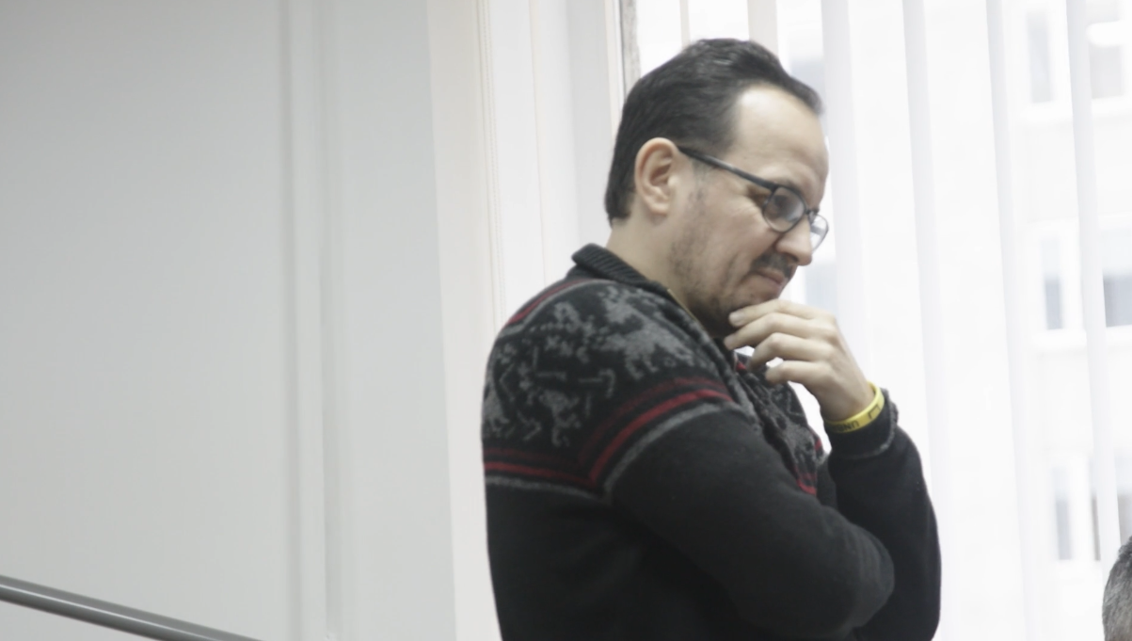
6 | 00:31 – 00:43 | A newly arrived patient at Lviv Clinical Hospital of Emergency and Intensive Care completes her physical rehabilitation exercises. This young woman was injured by shelling in Kyiv and has a brain injury as a result. She is receiving mental and physical rehabilitation at the hospital. | Lviv, Ukraine | Patient  Nurses | 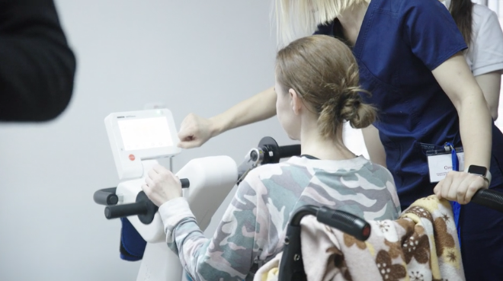
7 | 00:43 – 00:49 | Dr. Oleh Berezyuk, head of the psychotherapy program, speaks about a patient. | Lviv, Ukraine | Dr. Oleh Berezyuk | 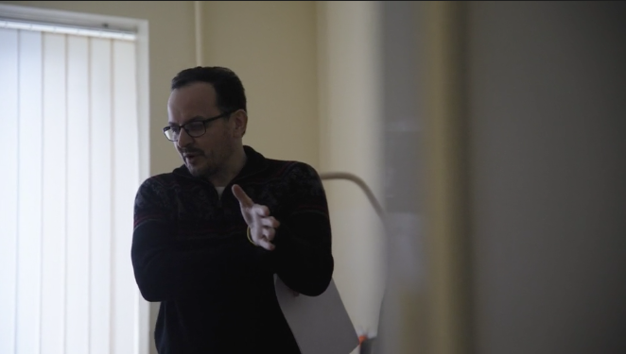
8 | 00:49 – 00:58 | A hallway in the inpatient ward of Lviv Clinical Hospital of Emergency and Intensive Care. | Lviv, Ukraine | Hospital staff | 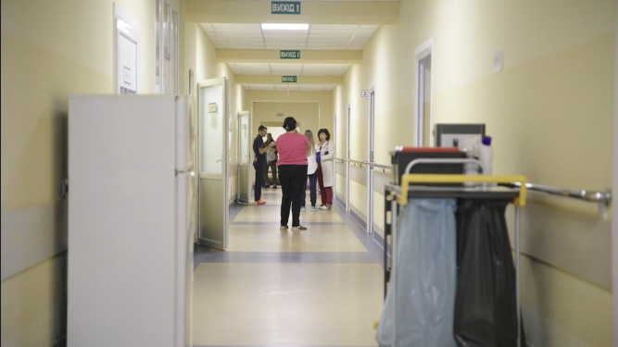
9 | 00:58 – 01:03 | Dr. Oleh Berezyuk, head of the psychotherapy program, enters a patient room with Ukrainian Red Cross and Canadian Red Cross personnel. | Lviv, Ukraine | Dr. Oleh Berezyuk  Canadian Red Cross personnel  Ukrainian Red Cross personnel | 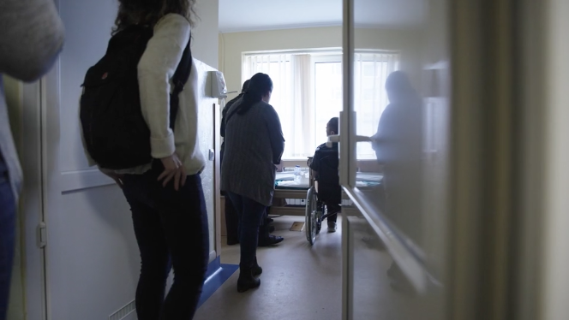
10 | 01:04 – 01:15 | Lviv Clinical Hospital of Emergency and Intensive Care staff. | Lviv, Ukraine | Hospital staff | 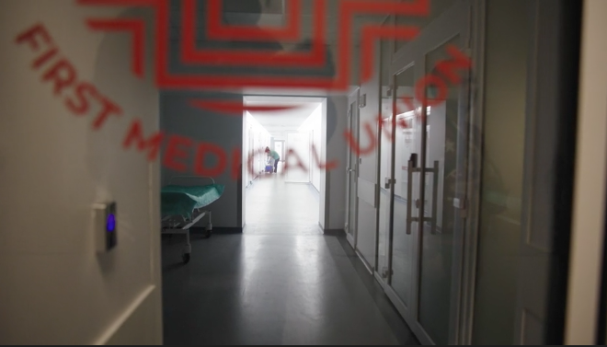
11 | 01:15 – 01:23 | A staff member of Lviv Clinical Hospital of Emergency and Intensive Care walks down an empty hallway. | Lviv, Ukraine | Hospital staff | 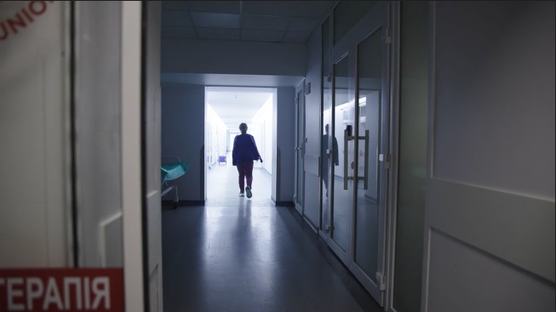
12 | 01:23 – 01:27 | A member of staff of Lviv Clinical Hospital of Emergency and Intensive Care pushes a patient in a wheelchair through a doorway. | Lviv, Ukraine | Hospital staff  Patient | 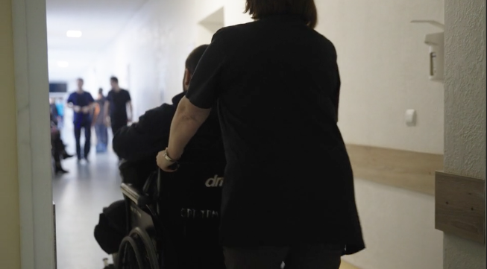
13 | 01:27 – 01:32 | An empty hallway at Lviv Clinical Hospital of Emergency and intensive Care. | Lviv, Ukraine | N/A | 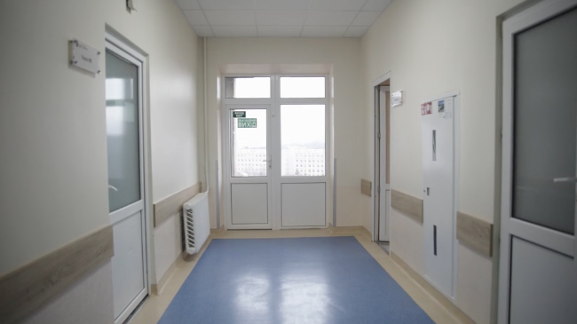
14 | 01:32 – 01:37 | Dr. Oleh Berezyuk speaks with Ukrainian Red Cross and Canadian Red Cross personnel while other personnel look on. | Lviv, Ukraine | Dr. Oleh Berezyuk  Ukrainian Red Cross personnel  Canadian Red Cross personnel | 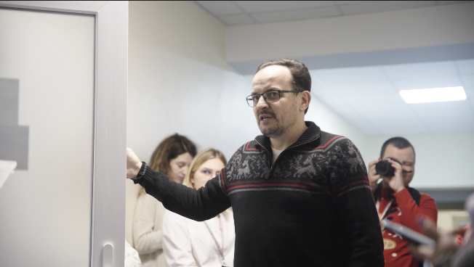
15 | 01:37 – 01:48 | Ukrainian Red Cross and Canadian Red Cross personnel walk through a doorway under a sign for the Lviv Clinical Hospital of Emergency and Intensive Care Department of Orthopaedics and Traumatology Trauma Centre. | Lviv, Ukraine | Ukrainian Red Cross personnel  Canadian Red Cross personnel | 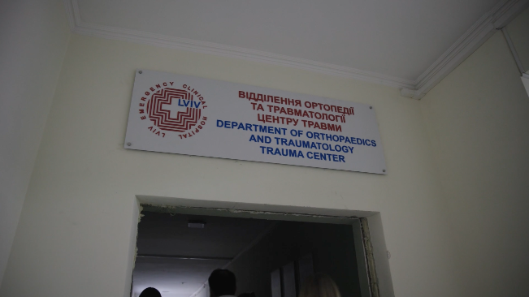
16 | 01:48 – 01:55 | A drawing that says “Unbroken”, which is the name of the National Rehabilitation Centre in Lviv, of which the psychotherapy program is part. | Lviv, Ukraine | N/A | 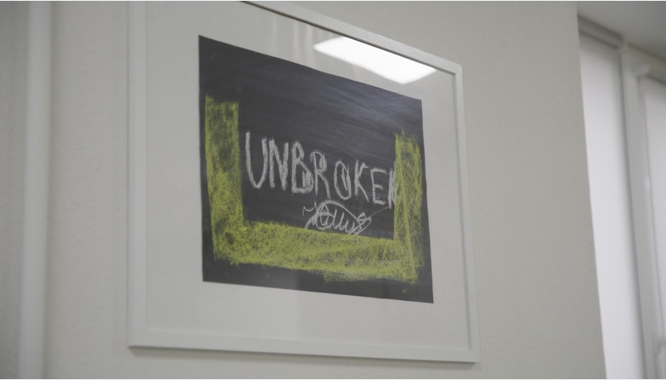
17 | 01:55 – 02:00 | A sign that reads “Mental Health Centre” in Ukrainian on the wall at the Lviv Clinical Hospital of Emergency and Intensive Care psychotherapy outpatient office. | Lviv, Ukraine | N/A | 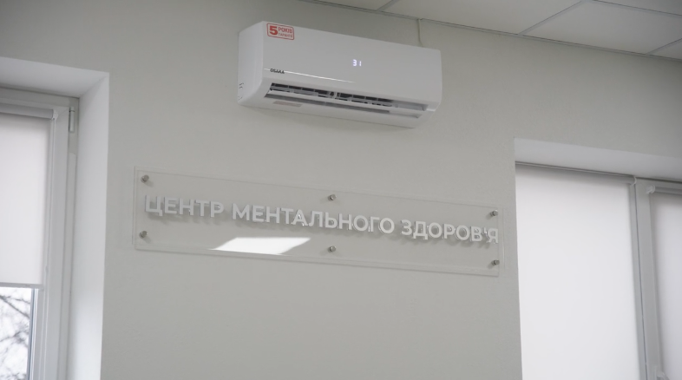
18 | 02:00 – 02:17 | Drawings done by patients, including former military and internally displaced people, during art therapy. Art therapy is one of the forms of therapy offered at the Lviv Clinical Hospital of Emergency and Intensive Care psychotherapy outpatient office. | Lviv, Ukraine | N/A | 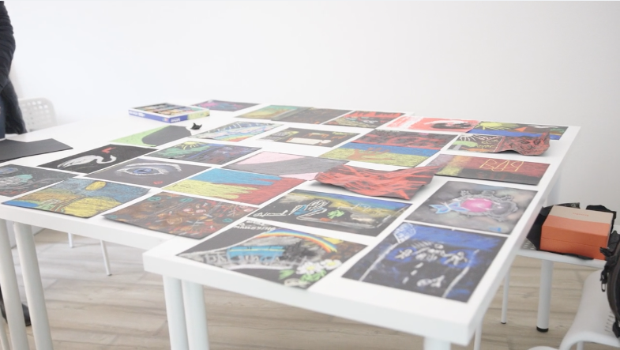
19 | 02:17 – 02:25 | A sign that reads “Art Therapy Room” in Ukrainian on the wall at Lviv Clinical Hospital of Emergency and Intensive Care psychotherapy outpatient office. | Lviv, Ukraine | N/A | 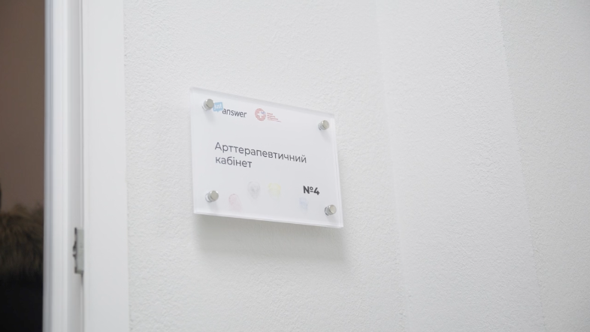
20 | 02:25 – 03:45 | Dr. Oleh Berezyuk, the psychotherapy program lead at Lviv Clinical Hospital of Emergency and Intensive Care, discusses the work the program does to integrate mental health treatment with treatment for physical injuries, and how the Canadian Red Cross has helped. | Lviv, Ukraine | Dr. Oleh Berezyuk | 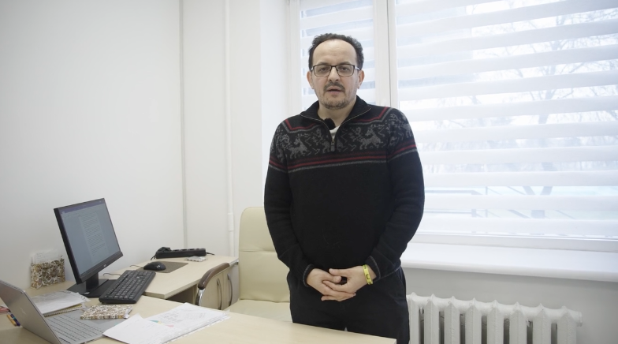
21 | 03:45 – 04:23 | Sofiya Nevoyt, a psychotherapist at Lviv Clinical Hospital of Emergency and Intensive Care, discusses what she sees in some of the patients coming to the hospital who have been impacted by the conflict. | Lviv, Ukraine | Sofiya Nevoyt | 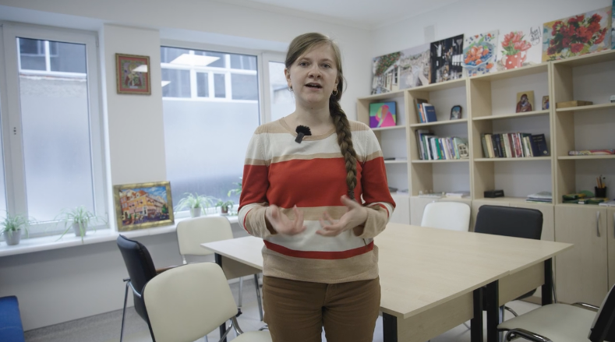
22 | 04:23 – 07:03 | Khrystyna Ruda, leader of the psychotherapy interdisciplinary team at Lviv Clinical Hospital of Emergency and Intensive Care, describes how the psychotherapy program has grown over the last several months, with help from the Canadian Red Cross. | Lviv, Ukraine | Khrystyna Ruda

Notes:

